

Gedling Borough Council
Community Infrastructure Levy (CIL)

Infrastructure Funding Statement 2023/24

Published December 2024

1 INTRODUCTION
Welcome to the Gedling Borough Council Infrastructure Funding Statement. This statement sets out the income and expenditure relating to the Community Infrastructure 4
Income collected from the CIL and / or s106 (collectively known as ‘planning obligations’ or ‘developer contributions’) is used to help fund the provision of infrastructure which is necessary to support and enable development and growth within the Borough.
Sections 2 and 3 of this statement will provide details of the progress in relation to the collection and expenditure of income generated through the CIL and s106 respectively for the last financial year.
Section 4 sets out the planned future expenditure of income generated through these mechanisms over the next reporting period.
1.1 Community Infrastructure Levy & Section 106 Agreements
The Community Infrastructure Levy is a tariff-based charge on the development of new floorspace within the borough. Monies collected through the CIL can be used to fund a wide range of infrastructure (e.g. roads, medical practices and the provision of open space) that is required to meet the future growth needs of the borough.
The Gedling Borough Community Infrastructure Levy (CIL) Charging Schedule was approved by Full Council on 15th July 2015 and came into effect on 16th October 2015. Planning applications decided on or after 16th October 2015 may therefore be subject to CIL.
Section 106 agreements are private agreements, made between local authorities and developers, which can be attached to a planning permission to ensure that a certain development that may otherwise be unacceptable in planning terms, meets the local planning authorities policy requirements. Typical forms of Section 106 Obligations include:
- Site-specific financial contribution;
- Non-financial obligations; and
- Provision of on-site affordable housing.
1.2 Summary of Headlines within Statement
Table 1. Key Headlines from the Statement.
Summary of CIL Receipts
A total of £2,853,486 in CIL receipts were collected during the financial year 2023/24.

A total of £2,237,110 receipts were retained at the end of the financial year 2023/24. Of this, £1,649,444 is to be used towards the provision of Strategic Infrastructure within the Borough, whilst £587,667 remains for the Council to expend on Infrastructure projects identified through the Neighbourhood portion of the CIL.

A total of £185,671 was passed to Local Parishes during 2023/24 in accordance with Regulations 59A.

A total of £142,674 was allocated to cover the administrative costs of implementing and monitoring the CIL during 2023/24.

Summary of Section 106 Contributions
During the 2023/24 financial year £409,749 was collected in capital contributions through Section 106 Obligations. £147,762 was collection in revenue contributions during the same period.

A total of £447,479 capital and £39,814 revenue contributions have been spent on infrastructure within Gedling Borough Council during the 2023/24 financial year.

At the end of the financial year 2023/24, £3,237,015 worth of capital contributions and £487,700 in revenue contributions were retained by Gedling Borough Council.

Obligations including Affordable Housing, Open Space and Local Labour Agreements were secured by way of Section 106 Obligations from two developments approved during 2023/24 with a further Deed of Variation signed in relation to a pre-existing Section 106 Agreement.
2 COMMUNITY INFRASTRUCTURE LEVY
The amount of CIL payable depends on where the development is located within the borough, the type of use the development comprises of, and the net additional increase in floorspace (£ per Sqm).
Gedling Borough Council’s Charging Schedule currently identifies two different types of Uses which are liable for the CIL. Retail development chargeable by a flat rate across the borough whilst new residential development is split into three different zones. The Charging Schedule and Map of the different zones are available to view from our website at https://www.gedling.gov.uk/cil/.
Alongside the Charging Schedule Gedling Borough Council also adopted a Regulation 123 List in accordance with the regulations in force at the time. Expenditure of the Strategic CIL receipt was approved for the following infrastructure projects:
- The Gedling Access Road (GAR);
- Secondary School Contributions for Gedling Colliery / Chase Farm and Top Wighay Farm strategic sites; and
- The Gedling Country Park Visitors Centre.
The Regulation 123 List has since been abolished as part of the CIL Amendment Regulations 2019 and replaced with the new ‘Infrastructure List’. Since the introduction of the CIL, the Strategic portion of the levy has been expended on the delivery of the GAR and the Gedling Country Park Visitors Centre. A consultation is scheduled to be undertaken in 2025 to identify additional Strategic projects that the levy could be expended on, in accordance with Regulations.
Unlike Section 106 Agreements, the CIL payable is a fixed rate which is mandatory and non-negotiable. The charge becomes payable upon the commencement of development.
2.1 CIL Income
Table 2 below provides a cumulative total of all CIL receipts retained by Gedling Borough Council since its first adopted of the CIL in 2015. A breakdown of these receipts is provided in greater detail further into the report.
Table 2. Cumulative Total CIL Receipts Retained (to the nearest £)
Year | Income
2015/16 | £0
2016/17 | £36,171
2017/18 | £420,148
2018/19 | £1,038,139
2019/20 | £1,276,677
2020/21 | £1,671,993
2021/22 | £4,272,039
2022/23 | £5,614,450
2023/24 | £2,237,110

Gedling Borough Council adopted the CIL on 16th October 2015. In accordance with the Community Infrastructure Levy (Amendment) (England) (No. 2) Regulations 2019, any planning application which was determined prior to this date is not chargeable. It is for this reason, along with a gap between the granting of permission and implemented, that no receipts were collected during the 2015/16 financial year. During the financial year 2023/24 Gedling Borough Council expended a total of £5,902,480 on Strategic Infrastructure Projects as set out in the Infrastructure List, previously known as the Regulation 123 List. A complete breakdown of the projects funded through the Strategic portion of the CIL can be found later in this Statement.
2.2 Breakdown of CIL for 2023/24
During the reported year 2023/24, 8 Demand Notices were issued totalling £1,796,607 in CIL Receipts. To date a total of £1,759,698 of these receipts have been collected. The remaining sums will be collected in accordance with the relevant payment plans as approved in the Councils Charging Schedule. The collection of the remaining sums from these Demand Notices will be reported in future Infrastructure Funding Statements in accordance with relevant payment policies.
During the reported year 2023/24 there has been a total of £2,853,486 collected in CIL receipts from across 16 different developments. A summary of the allocation of receipts collected during the year is detailed in Table 3 below.
Table 3. Annual Breakdown of CIL Receipts 1st April 2023 - 31st March 2024 (to the nearest £)
Total Receipts Collected | £2,853,486
Neighbourhood Portion of CIL Receipts | £496,927
Strategic Element of CIL Receipts | £2,213,885
Administration Element of CIL Receipts | £142,674
Receipts Spent on Strategic Infrastructure | £5,902,480
Receipts Passed to Local Parishes | £185,671
Receipts Awarded to Non-Parish Neighbourhood Projects | £0
CIL Receipts Retained at End of Year | £2,237,110

Of the receipts which were collected during 2023/24, £2,213,885 is to be spent on strategic infrastructure projects that were identified on the Infrastructure List (previously Regulation 123 List), while £496,927 is to be spent in the locality it was collected as part of the neighbourhood portion of the CIL.
In accordance with Regulation 59A of the Community Infrastructure Levy (Amendment) (England) (No. 2) Regulations 2019, a total of £185,671 from the Neighbourhood Portion of CIL Receipts has been passed directly to the Local Parishes from where they were collected.
£142,674 (5%) of all receipts collected during the financial year, have been set aside to cover the administration costs as permitted by the Community Infrastructure Levy (Amendment) (England) (No. 2) Regulations 2019.
During the 2023/24 financial year Gedling Borough Council spent approx. £5.9m of the Strategic portion of the CIL on the funding of the Gedling Access Road (GAR) and the Gedling Country Park Visitors Centre. This large outlay accounts for the reduction in CIL Receipts held at the end of the financial year 2023/24.
A total of £2,237,110 in CIL receipts were retained at the end of the financial year 2023/24.

2.2.1 Strategic CIL
Since its adoption of CIL, to the end of the financial year 2023/24, Gedling Borough Council has collected £7,551,924 towards the provision of its Strategic projects within the Borough.
Table 4. Annual Strategic CIL Collected (to the nearest £)
Year | Income
2015/16 | £0
2016/17 | £33,695
2017/18 | £333,580
2018/19 | £530,147
2019/20 | £332,116
2020/21 | £437,359
2021/22 | £2,430,843
2022/23 | £1,240,299
2023/24 | £2,213,885
Total | £7,551,924

Following its introduction in 2015, the strategic portion of the CIL collected has been retained for the construction of Gedling Access Road (GAR) which remained the Council’s priority in terms of key infrastructure within the Borough. During the reporting year the Borough Council completed the transfer of £4.44m of the Strategic portion of the CIL to Nottinghamshire County Council towards the funding of the Gedling Access Road (GAR). In addition to completing its obligation to fund the GAR through the CIL, Gedling Borough Council also funded the construction of the Gedling Country Park Visitors Centre through the Strategic Portion of the CIL as set out in the Regulation 123 List, now named the Infrastructure List. Gedling Borough Council transferred £1.454m of the Strategic CIL to fund the construction of the Gedling Country Park Visitors Centre.

Figure 1. Gedling Country Park Visitors Centre
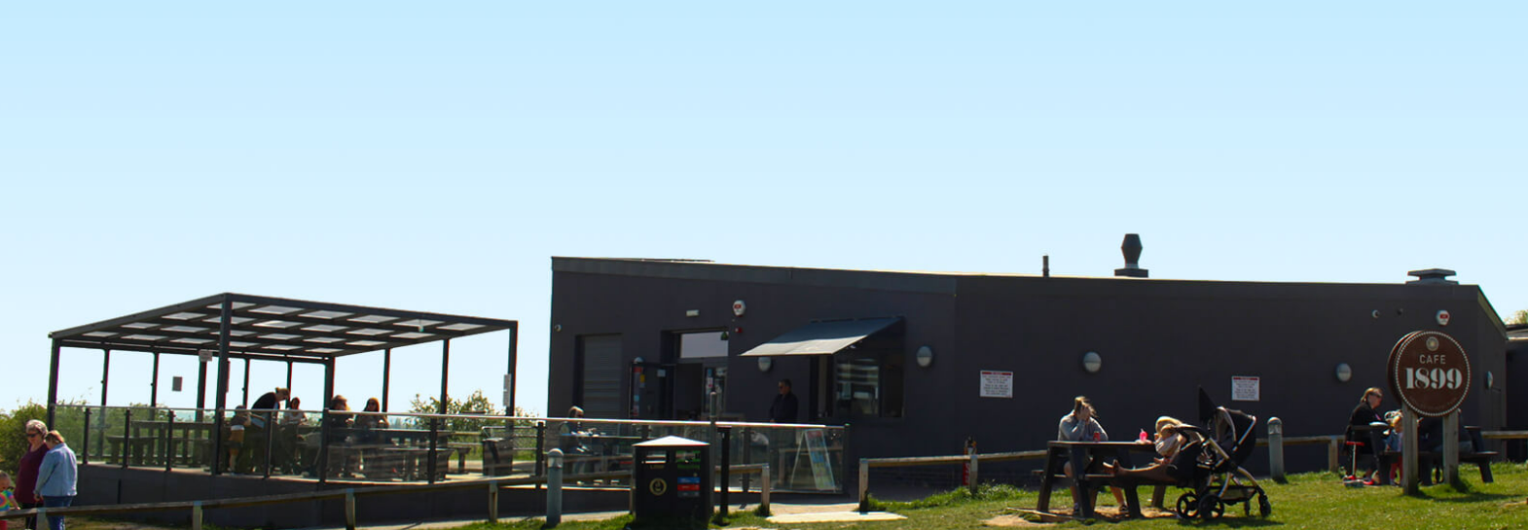
The Infrastructure List now contains only two Strategic Projects, Secondary School Contributions at Gedling Colliery / Chase Farm and Secondary School Contributions at Top Wighay Farm. It is therefore considered appropriate that suitable Strategic Projects are identified and assessed with a view to adding additional projects to the Infrastructure List to ensure that the Strategic portion of the CIL may continue to be allocated in accordance with the Community Infrastructure Levy (Amendment) (England) (No. 2) Regulations 2019.
2.2.2 Neighbourhood CIL
Under the Community Infrastructure Levy (Amendment) (England) (No. 2) Regulations 2019 a ‘meaningful proportion of CIL receipts are to be passed to local town or parish councils for the area where development takes place. This is known as the ‘neighbourhood portion’. The neighbourhood portion to be passed to the local council is set at 15% of the relevant CIL receipts (up to a cap of £100 per existing council tax dwelling) or 25% with no maximum cap specified where there is a Neighbourhood Development Plan in place. At this time there are four Neighbourhood Plans ‘made’ within Gedling Borough:
- Burton Joyce Neighbourhood Plan,
- Calverton Neighbourhood Plan,
- Linby Neighbourhood Plan, and
- Papplewick Neighbourhood Plan.
Table 5 below shows the portion of the Neighbourhood CIL Receipts which have been collected on behalf of local Parish Councils.
Table 5. Neighbourhood CIL Awarded to Local Parishes (to the nearest £)
Year | Income
2015/16 | £0
2016/17 | £3,842
2017/18 | £12,374
2018/19 | £8,059
2019/20 | £23,808
2020/21 | £45,304
2021/22 | £373,379
2022/23 | £232,190
2023/24 | £185,671
Total | £884,627

Where there is no Parish Council, Regulation 59A of the Community Infrastructure Levy (Amendment) (England) (No. 2) Regulations 2019 places a duty on charging authorities to allocate at least 15% (up to a cap of £100 per existing council tax dwelling) or 25% (uncapped) where there is a ‘made’ Neighbourhood Plan, of CIL receipts to spend on priorities that should be agreed with the local community in areas where development is taking place. Gedling Borough Council undertake annual consultations with local residents and groups to identify and assess projects which may be suitable for Non-Parish neighbourhood funding. Where no suitable projects are identified the Neighbourhood portion is carried over to the next financial year. Further information regarding the Neighbourhood portion of the CIL can be found on the Gedling Borough Council website at https://www.gedling.gov.uk/cil/.

Gedling Borough has 11 Parishes where the Neighbourhood portion of CIL Receipts will be passed to the Parish Councils if developments take place in those areas. The Parishes cover the following areas:

- Bestwood Village;
- Burton Joyce;
- Calverton;
- Colwick;
- Lambley;
- Linby;
- Newstead;
- Papplewick;
- Ravenshead;
- St Albans, and
- Woodborough.

In accordance with the Community Infrastructure Levy (Amendment) (England) (No. 2) Regulations 2019, Parish Councils must publish their own annual reports which detail funding and expenditure for each year where they have received monies passed down through the Neighbourhood Portion through CIL.
It should be noted that the extent of the Parishes does not cover the majority of the urban area of Gedling Borough (with the exception of Colwick). This creates a gap in the coverage for the Neighbourhood portion in the Borough. When development takes place in this area Gedling Borough Council will determine, in consultation with its residents, how to expend this element of the CIL in accordance with Regulation 59F of with the Community Infrastructure Levy (Amendment) (England) (No. 2) Regulations 2019.
Below is a table showing the amount of CIL which has been collected and allocated towards the Non-Parish Neighbourhood element during the last financial year.
Table 6. Non-Parish Neighbourhood CIL Collected (to the nearest £)
Year | Income
2015/16 | £0
2016/17 | £2,476
2017/18 | £50,397
2018/19 | £91,344
2019/20 | £46,423
2020/21 | £50,957
2021/22 | £249,963
2022/23 | £102,111
2023/24 | £311,256
Total | £904,927

To date Gedling Borough Council have awarded a total of £317,260 through the Non-Parish Neighborhood portion, to seven different infrastructure projects. Table 7 below provides a summary of these projects. The projects can be found in greater detail in the relevant annual Infrastructure Funding Statements which are available on the Gedling Borough Council website.

Table 7. Summary of Non-Parish Neighbourhood CIL Awards
Project | Award | Year of Submission
Cinderpath Lighting | £3,500 | 17/18
Car Park Extension at Gedling Country Park | £100,000 | 18/19
Changing Room Facilities at Lambley Lane | £40,000 | 18/19
Green Lung Corridor | £50,000 | 19/20
Arnold Marketplace Development | £43,000 | 19/20
Footpath Extension at Willow Park | £25,000 | 20/21
Internal works and alterations at Netherfield Forum Children, Young People and Families Hub | £55,760 | 20/21
During the financial year 2023/24, several projects which were nominated for the Neighbourhood portion of the CIL, in accordance with Regulation 59F of the Community Infrastructure Levy (Amendment) (England) (No. 2) Regulations 2019. A public consultation was undertaken in March 2024 and, following consideration of all representations, CIL Non-Parish Neighbourhood funding was awarded to a project to renovate the 1st Gedling Scouts Group HQ. The decision to award the funding was made outside the reporting year and as such will be fully detailed within next year’s IFS.

At the end of the financial year 2023/24 a total of £587,667 in CIL Receipts were retained by Gedling Borough Council for allocation towards the funding of future nominated projects. Below is a brief description of the latest projects which were granted awards through the Non-Parish Neighbourhood portion of the CIL.

2.2.3 CIL Administration Portion
The remaining 5% of monies collected through CIL Receipts is made available for Charging Authorities to cover the administrative costs associated with implementing and enforcing the CIL.
To date a total of £491,657 has been collected towards covering the costs of operating the CIL within Gedling Borough Council. Table 8 below shows a breakdown of the annual receipts collected towards this portion of the CIL.
Table 8. Administration CIL Collected (to the nearest £)
Year | Income
2015/16 | £0
2016/17 | £2,106
2017/18 | £20,861
2018/19 | £33,134
2019/20 | £21,176
2020/21 | £28,085
2021/22 | £160,747
2022/23 | £82,874
2023/24 | £142,674
Total | £491,657

3 SECTION 106 OBLIGATIONS
Gedling Borough Councils approach to planning obligations is set out within the Aligned Core Strategy 2014 (Part 1 Local Plan), the Local Planning Document 2018 (Part 2 Local Plan) and Gedling Borough Councils Planning Obligations Protocol 2014. Priorities which should be considered when negotiating planning applications include factors such as Affordable Housing, Open Space, Education and Primary Healthcare.
More detailed guidance regarding how obligations are calculated can be found in Gedling Borough Councils Supplementary Planning Documents and Guidance on the Gedling Borough Councils website at https://www.gedling.gov.uk/resident/planningandbuildingcontrol/planningpolicy/adoptedlocalplanandpolicydocuments/.
3.1 New Section 106 Agreements Signed
During the financial year 2023/24 there have been a total of 3 new planning permissions granted for developments which were subject to Section 106 Agreements or Deed of Variations. Table 9 below provides a list of these developments.
Table 9. List of New Section 106 Agreements 2023/24 (to the nearest £)
App Ref | Location | Breakdown of Obligations
2021/1398 | Land at Grange View Road, Gedling | Local Employment and Skills Plan.  20% Affordable Housing Units; Two (2) Affordable Rented Units and Three (3) First Homes.  Open Space Scheme to be submitted and approved.  Monitoring Fee £1,497
2022/0823  (Deed of Variation) | Orchard Close, Burton Joyce, Nottingham | No new obligations. Purpose of DoV is to enable the provision of On-Site Open Spaces.  Open Spaces Scheme to be submitted and approved.
2022/0200 | Land on West Side of Lambley Lane, Gedling, Nottingham | Local Employment and Skills Plan.  Three (3) Dwellings to be Affordable Rented Units and Two (2) Dwellings to be First Homes  Open Space Off-Site Contribution £63,122.64 (Capital) and £26,628.00 (Maintenance).  Monitoring Fee £2,084.35

A copy of each Section 106 Agreement and other public documents relevant to each Planning Application can be viewed electronically on the planning portal at https://pawam.gedling.gov.uk/online-applications/.
3.2 Section 106 Capital Contributions Overview
A total of £557,511 was received in Section 106 Contributions during the financial year 2023/24.
Table 10 provides a breakdown of the total contributions received from S106 Contributions and the amount of Expenditure over the last financial year.
Table 10. Overview of S106 Contributions 2023/24 (to the nearest £)
Contributions Received |  | Expenditure
Capital | Revenue | Capital | Revenue
£409,749 | £147,762 | £447,479 | £39,814

The above figures represent a slight decrease in the amount of contributions received during the last fiscal year, down from £642,731 capital and £156,980 in 22/23, however this not an unexpected change due to the reduction of larger developments which were commenced compared to the previous year. Irrespective of the slight reduction in contributions collected during 23/24 the Council, working collaboratively with its partners and stakeholders have increased the amount of both its capital and revenue expenditure during the latest fiscal year. This is a positive change which ensures that infrastructure is provided across the borough to improve the lives of Gedling’s residents and demonstrates the Councils commitment to ensuring that any adverse impacts of development are mitigated as part of the scheme. The Council will continue to monitor its Section 106 Contributions and ensure they are expended in accordance with the Regulations and in a timely manner.
Figure 3. Annual Comparison of S106 Income and Expenditure
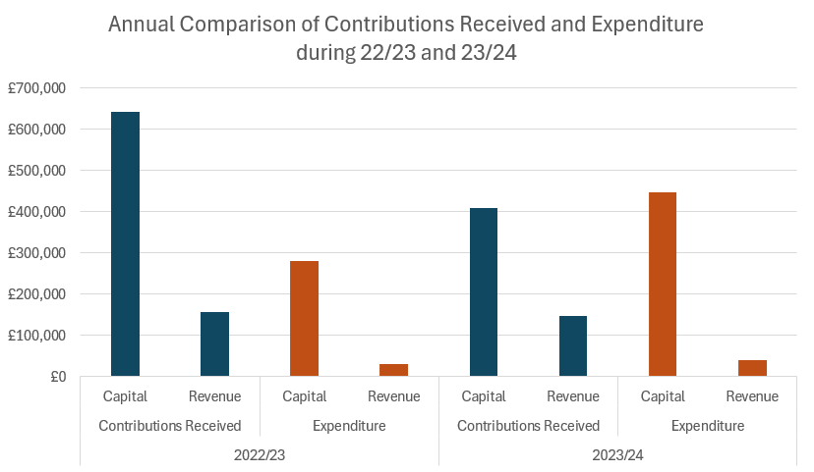
3.3 Capital Contributions retained at end of Financial Year 2023/24
Contributions collected through a Section 106 agreement usually have a clause stating the timeframe in which the contribution is to be expended. Currently there are no S106 contributions which have exceeded the timeframe and plans are in place to ensure that the contributions are expended prior to the repayment dates set.
In the majority of S106 agreements the payback period is usually 10 years however these clauses can range between 5 – 10 years.
Table 11 below details the Capital Contributions which have been retained at the end of the financial year 2023/24. As of the end of the financial year these monies were not yet allocated to a specific scheme or project.

Table 11. Capital Contributions held at 31st March 2024 (to the nearest £)
Site | Application Reference | S106 Received | Contributions Held | Provision | Deadline for expenditure
Spring Lane | 2007/0748 | 2014 | £24,924 | Affordable Housing | N/A
 |  |  | £11,863 | Open Space | 2024
Land at Wighay Road | 2014/0950 | 2016 | £35,170 | Open Space | 2026
 |  |  | £560,567 | Affordable Housing
 |  |  | £21,741 | Healthcare
Land at Stockings Farm | 2010/0437 | 2016 | £68,705 | Healthcare | 2026
Bradstone Drive, off Spring Lane | 2014/0740 | 2017 | £23,903 | Healthcare | 2027
Land North of Papplewick Lane, Linby | 2013/1406 | 2017 | £37,346 | Healthcare | 2027
 |  | 2018 | £215,568 | Affordable Housing | 2028
 |  | 2020 | £454,104 | Affordable Housing | 2030
 |  |  | £81,739 | Healthcare | 2030
Land Off Cavendish Road | 2014/0559 | 2017 | £13,943 | Open Space | 2027
Land at Teal Close, Netherfield | 2013/0546 | 2019 | £111,237 | Healthcare | 2029
 |  | 2023 | £147,483 | Healthcare | 2033
Land West of Westhouse Farm | 2014/0238 | 2019 | £27,818 | Healthcare | 2029
 |  | 2021 | £164,831 | Open Space | 2031
 |  | 2021 | £54,939 | Open Space | 2031
Land west of Beeston Close, Bestwood | 2017/0194 | 2020 | £36,251 | Open Space | 2030
Bradstone Drive, off Spring Lane | 2014/0740 | 2020 | £22,692 | Healthcare | 2030
Land to the West of Mapperley Plain | 2019/0213 | 2020 | £99,875 | Healthcare | 2030
Rolleston Drive | 2020/1054 | 2021 | £250,688 | Education | 2031
 |  |  | £25,000 | Bus Stop | 2031
 |  |  | £35,493 | Healthcare | 2031
 |  |  | £78,197 | Open Space | 2031
96 Plans Road Mapperley | 2021/0737 | 2021 | £17,636 | Open Space | 2031
84-86 Chapel Lane, Ravenshead | 2019/0770 | 2021 | £30,359 | Open Space | 2031
Dark Lane | 2017/1263 | 2021 | £39,862 | Open Space | 2031
 |  |  | £18,713 | Healthcare | 2031
 |  | 2022 | £53,037 | Affordable Housing | £53,037
Glebe Farm | 2014/0475 | 2021 | £15,028 | Healthcare | 2031
Metallifacture, Land West of Mansfield Road | 2016/0854 | 2022 | £142,819 | Affordable Housing | 2032
 |  | 2022 | £42,692 | Healthcare | 2032
Cornwater Fields | 2013/0836 | 2022 | £103,224 | Open Space | 2032
Wood Lane | 2018/0577 | 2022 | £19,681 | Open Space | 2032
Burton Road | 2019/1186 | 2022 | £79,549 | Healthcare | 2032
Flatts Lane | 2018/1143 | 2022 | £14,609 | Healthcare | 2032
53 Woodthorpe Drive | 2020/1312 | 2023 | £9,514 | Healthcare | 2033
Land at Ashdale, Nottingham Road | 2020/0238 | 2023 | £46,215 | Open Space | 2033
Total |  |  | £3,237,015

It is noted that the Open Spaces Contribution of £11,863 from the Spring Lane development should be allocated or expended by the end of 2024. The Contribution has been identified and allocated to part fund the Sand Martin Bank & Bird Hide at Gedling Country Park, see table 17 for 2024/25 commitments. In accordance with these commitments the monies will be spent before the relevant deadline and reported in next year’s Infrastructure Funding Statement.
Figure 4 below provides a breakdown of all the contributions currently held by Gedling Borough Council per service provision.

Figure 4. Pie Chart showing S106 Contributions held per type of provision
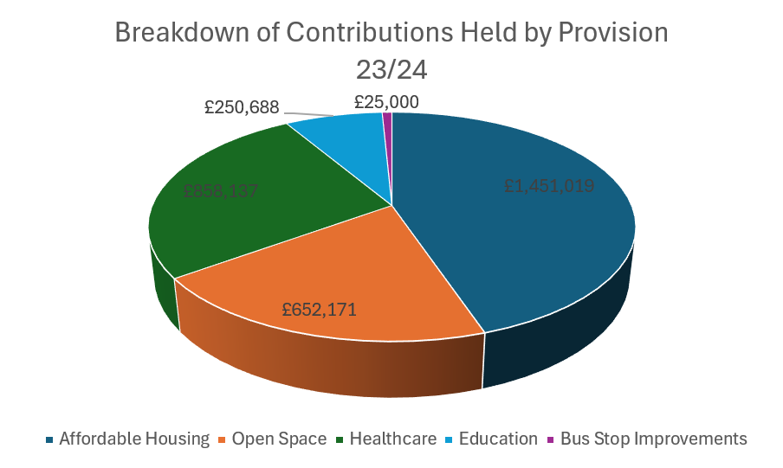
It should be noted that during the financial year 2021/22 Gedling Borough Council collected financial contributions, as part of Section 106 Agreements, towards the provision of both Education and Bus Stop Improvements. Whilst it is typically the responsibility of Nottinghamshire County Council to collect contributions regarding Education and Highways Improvements, in each of the relevant cases above, the County Council were the applicants for planning permission and as such were unable to collect the monies from themselves. Gedling Borough Council have transferred the Contributions to Nottinghamshire County Council during the 24/25 financial year and as such this transaction will be reported within the Councils next annual IFS.
3.4 Section 106 Capital and Revenue Expenditure
During the financial year 2023/24 Section 106 Contributions totalling £447,479.27 were spent on infrastructure across the borough. Table 12 indicates which developments the contributions were drawn down from and what projects they were allocated to.

Table 12. Capital Contributions expended during 2023/24 (to the nearest £)
Site | Application Reference | S106 Contribution Received | Amount Spent | Provision/Project Funded
Cavendish Road | 2014/0559 | 2018 | £21,300 (Open Space) | Lambley Lane Changing Rooms
Land at Wighay Road | 2014/0950 | 2014 | £59,652.67 (Open Space) | Linby Parish Council Heritage Centre
Stockings Farm | 2010/0437 | 2016 | £366,526.60 (Healthcare) | Stenhouse Medical Centre
Total |  |  | £447,479.27

As well as the collection and expenditure of capital contributions, it is not uncommon for Section 106 Agreements to require the payment of revenue contributions towards the ongoing maintenance of infrastructure which is provided. These payments are typically agreed for a period of 10 years. The majority of revenue contributions which are collected by Gedling Borough Council relate primarily to ongoing maintenance works on Open Spaces sites that the Council have adopted. Table 13 below sets out revenue contributions which have been collected by the Local Authority and the developments they have been spent on thus far.
Table 13. Open Spaces Revenues Contributions 23/24
Site | Date Received | Balance as of 1st April 2023 | Annual Payment 2023/24 | Remaining Balance as of 31st March 2024
Spring Lane | 2006 | £1,138 | £569 | £568
Park Road, Bestwood | 2006 | £17,880 | £0 | £17,880
Downham Close, Arnold | 2008 | £1,651 | £825 | £825
Arnold View Primary School | 2009 | £7,424 | £2,474 | £4,950
Burton Road, Gedling | 2009 | £1,529 | £763 | £766
188-194 Mapperley Plains | 2016 | £5,710 | £1,904 | £3,806
333-339 Mapperley Plains | 2016 | £7,226 | £2,409 | £4,817
Land at Wighay Road | 2016 | £,39,385 | £0 | £39,385
Spring Lane | 2017 | £44,231 | £11,057 | £33,174
Land at Teal Close, Netherfield | 2018 | £2,550 | £0 | £2,550
Land Between Main St and Hollinwood | 2019 | £99,536 | £0 | £99,536
Howbeck Road | 2020 | £21,668 | £3,096 | £18,572
Land west of Beeston Close | 2020 | £12,277 | £0 | £12,277
Bailey Drive | 2022 | £59,688 | £6,632 | £53,056
Wood Lane | 2022 | £8,223 | £0 | £8,223
Teal Close | 2023 | £100,846 | £10,085 | £90,761
84-86 Chapel Lane, Ravenshead | 2022 | £13,500 | £0 | £13,500
Cornwater Fields | 2022 | £46,876 | £0 | £46,876
Rolleston Drive | 2023 | £35,561 | £0 | £35,561
Ashdale | 2023 | £19,446 | £0 | £19,446
Westhouse Farm | 2024 | £20,556 | £0 | £20,556
Total |  | £527,516 | £39,814 | £487,700

3.5 Section 106 Monitoring Fees
The Community Infrastructure Levy (Amendment) (England) (No. 2) Regulations 2019 introduced a provision for Local Authorities to insert Monitoring Clauses into future Section 106 Agreements. These clauses allow fees to be levied to support the costs of monitoring and reporting on the delivery of Section 106 planning obligations.
Whilst the amendments to the Regulations allows for monitoring fees to be levied, any such fee must be both fair and reasonable based on the Local Authorities estimates of the actual costs of monitoring the agreement. The Borough Council has an adopted policy which can be viewed on the council’s website at the following link - https://democracy.gedling.gov.uk/documents/s16689/Appendix%201%20Monitoring%20Fee%20Ststement.pdf.
During the financial year 2023/24 Gedling Borough Council completed a total of 2 Section 106 Agreements which include the provision of a Monitoring Fee in accordance with the above policy. A list of these developments and the relevant monitoring fees, including monitoring fees which have been sought in relation to pre-existing agreements, are detailed below. Upon receipt of the monitoring fee the relevant records will be removed from the table.
Table 14. Section 106 Agreements with Monitoring Fees (to the nearest £)
Site | Date S106 Signed | Value of Monitoring Fee | Status
Land On Flatts Lane, Calverton, Nottinghamshire | 03.03.2020 | £2,835 | Payment Due
Land at Orchard Close, Burton Joyce, Nottinghamshire | 26.03.2020 | £2,520 | Payment Due
Land at Brookfields Garden Centre, Mapperley Plains, Nottingham, NG3 5RW | 26.03.2020 | £2,205 | Not Commenced
Land at Chase Farm, Mapperley Plains, Mapperley, Nottingham | 09.07.2020 | £1,890 | Not Commenced
Land South Of Main Street, Calverton, Nottinghamshire | 07.04.2021 | £2,205 | Not Commenced
Land East of 16 Kighill Lane, Ravenshead, Nottinghamshire | 22.04.2021 | £315 | Payment Due
Car Park, North Green, Calverton, Nottinghamshire | 11.06.2021 | £630 | Payment Due
Top Wighay Farm, Wighay Road, Linby, Nottinghamshire | 25.03.2022 | £5,040 | Not Commenced
Total |  | £17,640

3.6 Non-Monetary Contributions
In some instances, financial contributions may not be deemed necessary to mitigate against the impacts of a development. Instead, it may be considered that the provision of on-site infrastructure such as Affordable Housing or, the agreement of future plans such as Local Employment Schemes may be sufficient.
Table 15 details developments approved during the reporting year which include a provision to provide Affordable Housing on site.
Table 15. Provision of Affordable Housing 2023/24
Site Address | Application Reference | Date S106 Signed | Affordable Housing Obligation
Land on West Side of Lambley Lane, Gedling, Nottingham | 2022/0200 | 15th December 2023 | Three (3) Dwellings to be Affordable Rented Units and Two (2) Dwellings to be First Homes
Land at Grange View Road, Gedling | 2021/1398 | 31st March 2023 | 20% Affordable Housing Units Two (2) Dwellings to be Affordable Rented Units and Three (3) Dwellings to be First Homes.

Where appropriate, Section 106 Agreements also create opportunities to work with developers to ensure that, as well as providing a safe and attractive place to live for local residents to live, developments can provide a chance to support and improve the lives of our local residents by agreeing Employment and Skills Plans, also known as Local Labour Agreements. Through these Employment and Skills Plans it is possible to increase workplace opportunities for local residents and involve our younger communities to increase skill sets and education.
Of the Section 106 Agreements completed in 2023/24, two included a requirement to submit an Employment and Skills Plan to the Local Planning Authority for signing off. Table 16 details the developments which require such obligations.
Table 16. Employment and Skills Plans Agreed 2023/24
Site | Date S106 Signed
Land on West Side of Lambley Lane, Gedling, Nottingham | 15th December 2023
Land at Grange View Road, Gedling | 31st March 2023

3.7 Monies Borrowed
No Section 106 monies were spent repaying money borrowed during the financial year 2023/24.
4 GOING FORWARD – PLANNED EXPENDITURE
In accordance with the latest amendments to the CIL Regulations, the IFS outlines the future priorities in terms of expenditure over the next reporting period (2023/24).
The amount of CIL receipts generated in any given financial year is dependent upon the implementation of planning permissions and phasing of developments. Whilst it is possible to calculate the amount of CIL receipts expected through the totalling of Liability Notices generated, this will only ever be a theoretical figure as payment only becomes due upon the commencement of development.
Contributions generated through Section 106 Agreements must be spent in accordance with the terms set out within each Agreement (as negotiated during the planning application process). These terms will often have several trigger points, such as number of residential units occupied, which will cause the payment to become due. In this way, funding obtained through Section 106 agreements are heavily reliant upon the phasing and delivery of development and can vary greatly on a site by site basis, making it difficult to accurately forecast future income.
4.1 Strategic CIL
Since Gedling Borough Council first adopted the CIL in 2015 the Strategic portion of CIL Receipts have been ring-fenced for the provision of the Gedling Access Road (GAR).
Gedling Borough Council have now fulfilled its commitment to deliver a contribution towards the construction of the Gedling Access Road (GAR) through the Strategic portion of the CIL Receipts. The Council have also funded the Gedling Country Park Visitors Centre and therefore the two remaining projects on the Infrastructure List are Secondary School Contributions at Chase Farm, Gedling and Top Wighay Farm, Linby.
To ensure that the Council continue to have projects on which to expend the Strategic portion of the CIL a review of its list of remaining Strategic projects is proposed to be undertaken in 2025. The review will identify suitable projects to replace the now completed GAR and Gedling County Park Visitors Centre. Any review of the Infrastructure List will be subject to a public consultation to ensure transparency and to provide the opportunity for local residents and stakeholders to also suggest projects.
4.2 Neighbourhood Portion CIL
The Neighbourhood CIL will continue to be spent on providing and improving existing infrastructure within the Borough. 15% of CIL receipts will continue to be allocated to the Neighbourhood portion of the CIL rising to 25% in places where a Neighbourhood Plan has been adopted.
The Neighbourhood portion of CIL receipts collected in local parishes will continue to be transferred directly to these governing bodies for allocation.
Throughout the year, local community groups and stakeholders will be able to nominate projects for the Neighbourhood portion of the CIL receipts which are collected within non-parish areas. Submissions can be made by completing the electronic form on the Gedling Borough Council website at the following link - https://apps.gedling.gov.uk/forms/default.aspx?formid=86.
In accordance with the CIL Regulations and Gedling Borough Councils CIL Guidance Note, an assessment of all the projects nominated throughout the year will commence in October. A Local Infrastructure Schedule (LIS) will be published along with a comprehensive project assessment for review prior to CIL Non-Parish Funding awards being granted. Following the publication of the LIS and project assessment a public consultation will be undertaken and a final report identifying which if any projects have been successful. If no projects are nominated or deemed appropriate the Neighbourhood CIL will be carried over to the next financial year.
Examples of types of Infrastructure which may be appropriate include:
- Improvements to local open spaces;
- Street improvements;
- Drainage improvements;
- Town centre regeneration and
- Recreational facilities.
It is important that any project which is nominated is able to demonstrate how it fulfils a need created by new development within the area and, should wherever possible, show availability to provide match funding through other revenue streams.
4.3 Section 106 Contributions
The Gedling 2024/25 capital programme sets out the future spending priorities of Gedling Borough Council. There are currently five infrastructure projects identified to be funded through Section 106 Contributions in the next financial year 24/25, with a total cost of £428,093. The projects total which have been identified so far as suitable for Section 106 funding are detailed in table 17 below.
Table 17. Section 106 Contributions 2024/25 Allocations
Open Spaces
Sand Martin Bank & Bird Hide at Gedling Country Park £29,500, funded by £11,900 from Spring Lane 2007/0748 Contributions, £17,600 from 96 Plains Road 2021/0737 Contributions.
Lambley Lane Footpath Entrance £19,681 from Land at Wood Lane 2018/0577 Contributions.
Ravenshead Leisure Centre Improvement Works £103,224 from Land known as Cornwater Fields off Longdale Lane 2013/0836.
Affordable Housing
Circa £60,000 Section 106 Contributions committed for Development of Affordable Housing at Station Road / Burton Road.
Healthcare
No funding committed for 24/25 to date.
Education
Transfer of Education Contribution £250,688 from Rolleston Drive 2020/1054 to Nottinghamshire County Council as the Local Education Authority.
Transport
Transfer of Bus Stop Contribution £25,000 from Rolleston Drive 2020/1054 to Nottinghamshire County Council as the Local Transport Authority.

Careful consideration will be given to remaining Section 106 Contributions which are being held by Gedling Borough Council. These remaining sums will be monitored, and projects identified in accordance with the relevant legal S106 Agreements.
5 Infrastructure List
Table 18. The Infrastructure List
Community Infrastructure Levy
Secondary School Contributions at Gedling Colliery / Chase Farm. | To be funded through Strategic portion of CIL Receipts collected.
Secondary School Contributions at Top Wighay Farm developments. | To be funded through Strategic portion of CIL Receipts collected.
Annual assessment of suitable Infrastructure projects identified in accordance with Regulation 59F of the Community Infrastructure Levy (Amendment) (England) (No. 2) Regulations 2019. | To be funded through the Neighbourhood portion of CIL Receipts collected.
Section 106 Contributions
Provision of Affordable Housing Units either on-site of through capital contributions. | To be secured through Section 106 Obligations.
Provision of Open Spaces including new infrastructure and improvements to existing sites. | To be secured through Section 106 Obligations.
Provision for Primary Healthcare including new infrastructure and improvements of existing surgeries. | To be secured through Section 106 Obligations.
Any other future infrastructure which is deemed necessary, in accordance with the Community Infrastructure Levy (Amendment) (England) (No. 2) Regulations 2019 | To be secured through Section 106 Obligations.

The above is not a final account of all infrastructure that may be funded through Planning Obligations. The Infrastructure List will be monitored and may be updated accordingly to represent new projects that are identified in the future.
If you have any further queries or comments about this statement, please do not hesitate to contact us via email at CIL@gedling.gov.uk or phone on 0115 901 3731.

